Issue No.1 April 2026 Newsletter
Welcome to Issue No.1 of The New Surgery PPG Newsletter. The PPG was established in March 2025 and has spent the last 12 months getting to know patients and the practice team. We welcome new members.
To achieve this, we have held monthly meetings, assisted at Flu/Covid Vaccination clinics, held patient surveys, reviewed and discussed Friends and Family patient feedback with the practice management team and trained staff and patients on the usage and benefits of using the NHS APP.
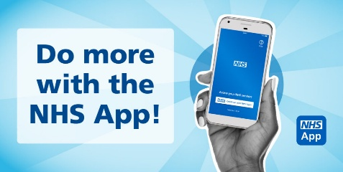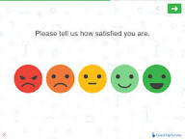

PPG Events: NHS APP advice and guidance sessions were held at the surgery between 10.30-12.30, Tuesday 17th February and Tuesday 10th March 2026. There will be other sessions held later in 2026.
Friends and Family Feedback: 309 patients completed – 264 (84.8%), Very Good – 32 (10.2%) Good – 7 (2.2%) Neither Good nor Poor, 3 (0.9%) Poor – 3 (0.9%) Very Poor. All Poor or Very poor comments are discussed in full with practice management to ensure better patient experiences.
Digital Transformation October 2025 Survey – NHS APP and Triage Usage – another survey will be held summer 2026
Have you used the online triage system?
Yes | No
2 | 26
Do you make appointments using the NHS APP?
Yes | No
3 | 23

