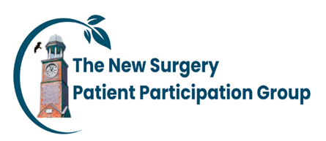
Patient Participation Group Roundup January 2026
Date | Item
September 2025 | - Members attended the Bucks, Berks, and Oxon Integrated Care Board /Healthwatch – Bucks PPG Network Meeting.  Items discussed: Healthwatch Bucks update / Frailty Virtual Care Pilot Bucks / BOBICB Integrated Neighbourhood Teams update.
October 2025 | - PPG Notice Board No. 1 purchased and displayed in waiting room of Practice Staff including ARRS staff.  - Flu/Covid clinic – PPG members assisted the practice team at a Flu/Covid Saturday clinic  - Digital Transformation: survey relating to the new Triage system, Services feedback, and NHS APP usage conducted – results to be published in Newsletter  - Practice Administration Staff training completed – usage and benefits of NHS APP.
November 2025 | - PPG Notice Board No.2 purchased and displayed in waiting room of PPG membership information, PPG events, and Newsletter  - Review of Numed TV Screen information  - Digital Transformation: Patient survey feedback reviewed and discussed with Practice management team.  - Patient NHS APP sessions agreed to be arranged in early 2026, delivered by PPG members.
December 2025 | - Friends and Family feedback reviewed and discussed with Practice management team  - NHS APP session dates agreed to be held in 2026 in the practice education room.
January 2026 | - NHS APP sessions - Advertising Literature completed and invites sent out to interested patients for February session.  - PPG Newsletter – items of interests for publication agreed upon.  - New initiatives: Jess’ Rule – discussed and advertised within the practice.  - PPG 2026 Goals – discussed and agreed upon:  - Recruitment of additional members  - NHS App – delivery of 2 x patient sessions, Feb and March  - PPG Newsletter – quarterly publication

