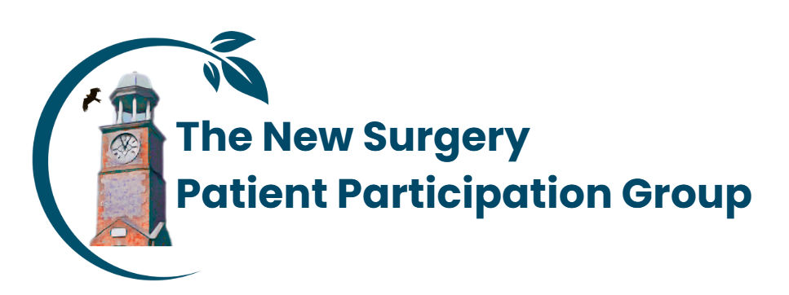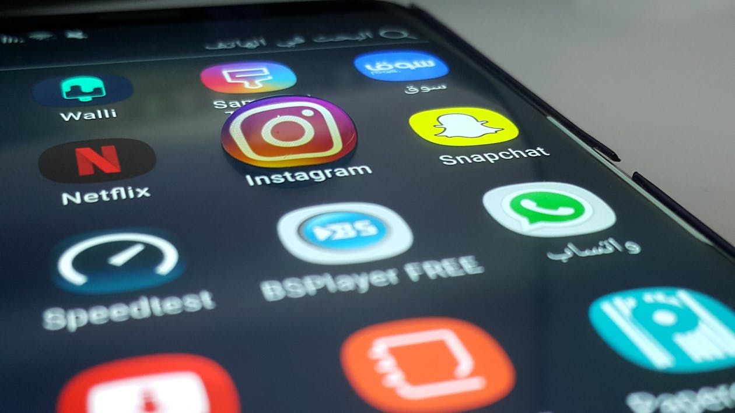
NHS APP ADVICE AND GUIDANCE SESSIONS
ALL PATIENTS ARE WELCOME TO ATTEND, COME AND LEARN HOW TO INSTALL AND USE THE NHS APP TO YOUR BENEFIT

ACCESS SERVICES / MANAGE YOUR HEALTH / READ AND SEND MESSAGES / ACCOUNT AND SETTINGS
Request repeat prescriptions Check for GP surgery appointments
Contact your GP surgery Use 111 online
Browse NHS health information OR NHS medical information
Find NHS services View your GP health record
Manage appointments Manage prescriptions
Manage your account and settings Receive messages and notifications
Date: Tuesday 16th June 2026, 10.30 a.m. – 11.30 a.m.
Venue: The New Surgery

What you will need to bring with you / know

- Pen and paper - easy to take notes first then follow your own directions.
- Tablet, laptop or phone to use for the App
- Email address (not a shared address with a partner, husband, or wife) with access to new messages
- Smart Phone to receive text messages
- Full name / Date of birth
- NHS number
- Proof of who they are: Passport or driving license.

